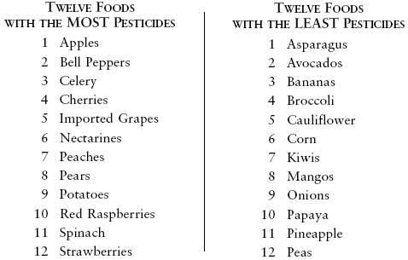
This list can change each year, so check it yearly.

Organic vs. Conventional Meat and Dairy
Regulations governing meat and dairy farming vary from country to country. In the U.S., these conventionally grown meats and dairy products were found to have the lowest levels of pesticides.
Organic meat and dairy:  No antibiotics, hormones, or pesticides are given to animals  - Livestock are given all organic feed.  - Disease is prevented with natural methods such as clean housing, rotational grazing, and a healthy diet.  - Livestock must have access to the outdoors. | Conventionally raised meat and dairy:  Typically given antibiotics, hormones and feed grown with pesticides  - Livestock are given growth hormones for faster growth.  - Antibiotics and medications are used to prevent livestock disease.  - Livestock may or may not have access to the outdoors.

Understanding organic food labels
What do the food labels such as “organic,” "natural," "free-range," and "non-GMO" really mean? Understanding this terminology is essential when you’re shopping for organic foods.
The most important point to remember is that "natural" does not equal organic. "Natural" is an unregulated term that can be applied by anyone, whereas organic certification means that set production standards have been met. These production standards vary from country to country—in the U.S., for example, only the "USDA Organic" label indicates that a food is certified organic. Similar certification labels are also offered on organic products in other parts of the world, including the European Union, Canada, and Australia.

USDA Certified Organic Food Labels in the U.S.
When you’re shopping for organic foods in the U.S., look for the “USDA Organic” seal. Only foods that are 95 to 100 percent organic can use the USDA Organic label.
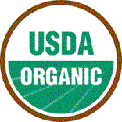
- 100% Organic – Foods that are completely organic or made with 100% organic ingredients may display the USDA seal.
- Organic – Foods that contain at least 95% organic ingredients may display the USDA seal.
- Made with organic ingredients – Foods that contain at least 70% organic ingredients will not display the USDA seal but may list specific organic ingredients on the front of the package.
- Contains organic ingredients – Foods that contain less than 70% organic ingredients will not display the USDA seal but may list specific organic ingredients on the information panel of the package.

What does "Certified Organic" mean in the U.S.?
Keep in mind that even if a producer is certified organic in the U.S., the use of the USDA Organic label is voluntary. At the same time, not everyone goes through the rigorous process of becoming certified, especially smaller farming operations. When shopping at a farmers’ market, for example, don’t hesitate to ask the vendors how their food was grown.
Source: Organic.org

What’s in American meat?
It is helpful to understand what the U.S. government allows in feed or to be used in conventional production:
- Dairy cows – antibiotics, pig & chicken byproducts, hormones (for growth), pesticides, sewage sludge
- Beef cows – antibiotics, pig & chicken byproducts, steroids, hormones, pesticides, sewage sludge
- Pigs – antibiotics, animal byproducts, pesticides, sewage sludge, arsenic-based drugs (growth hormones are prohibited)
- Broiler chickens – antibiotics, animal byproducts, pesticides, sewage sludge, arsenic-based drugs (growth hormones are prohibited)
- Egg laying hens – antibiotics, animal byproducts, pesticides, sewage sludge, arsenic-based drugs
Source: Meat, dairy, and eggs buying guide

Meat and dairy labels: other terms you need to know
The organic label is the most regulated term, but when it comes to meat, we often see many other terms used. In order to make informed choices, it is helpful to know what some of these terms mean, although their use can often vary from country to country.
- Natural – In the U.S., this label means “minimally processed” and that the meat can’t have any artificial colors, artificial flavors, preservatives, or any other artificial ingredients in it. Animals can still be given antibiotics or growth enhancers. For example, this term can be applied to all raw cuts of beef since they aren’t processed.
- Grass fed – This term means that the animals are fed solely on a diet of grass or hay. These animals have access to the outdoors. Cattle are naturally ruminants that eat grass, so they tend to be healthier and leaner when fed this way. In addition, grass fed beef has been shown to have more of the healthy omega-3 fatty acids.
- Free range – Again the term “free range” means slightly different things in different parts of the world. Broadly, it means that the animals weren’t confined to a cage and had access to the outdoors. Unfortunately, in the U.S. at least, the animal density can still be very high and the animals may have only short periods outside in an area that’s quite small. Therefore, it is difficult to tell exactly what free range means when you see it on meat packaging in the U.S. You can contact the producer directly for clarification.
- No hormones added – In the U.S. and some other countries where the use of growth hormones is permitted, this term indicates that animals are raised without the use of any added growth hormones. For beef and dairy products it can be helpful, but by law, poultry and pigs cannot be given hormones, so don’t pay extra for chicken or pork products that use this label.

