Geopathic Stress/EMF: (from a prior presentation below)

If you cannot shake off an illness, depression or feel below par, ask yourself:

- Did my health problem begin shortly after moving into this home or place of work?
- Do I feel better when I am away from the home or place of work?
- Do any of my family feel uneasy about the ‘atmosphere’ at home?
- Did the previous occupant’s suffer from any serious or long term illness?
- Does the illness seem to be worse during autumn or spring or wet stormy weather?
  - (When underground water may be flowing at higher velocity)
- Were there any nearby disturbances, which may have caused underground water veins to flow into different channels under my house prior to my illness? (landslides, building and road work, working quarries and mines etc)
- Does my home or any part of it feel unnaturally cold or damp?

Some research shows:

- 100% of people who get SECONDARY CANCER.
- 95% of people who get CANCER were sleeping and/or working in a GS place before or at the time the cancer was diagnosed.
- 95% of children who are HYPERACTIVE, have LEARNING DISABILITIES or are DIFFICULT TO CONTROL.
- 95% of people who get AIDS.
- 80% of parents/caregivers who ABUSE CHILDREN.
- 80% of DIVORCES are by one or both partners being GS.
- 80% of couples who CANNOT HAVE BABIES, one or both are GS.
- 80% of women who have a miscarriage.
- 80% of babies who died of COT DEATH.
- 70% of M.E. (Post Viral Fatigue) sufferers.
- 70% of people who are ALLERGIC TO FOOD/DRINK.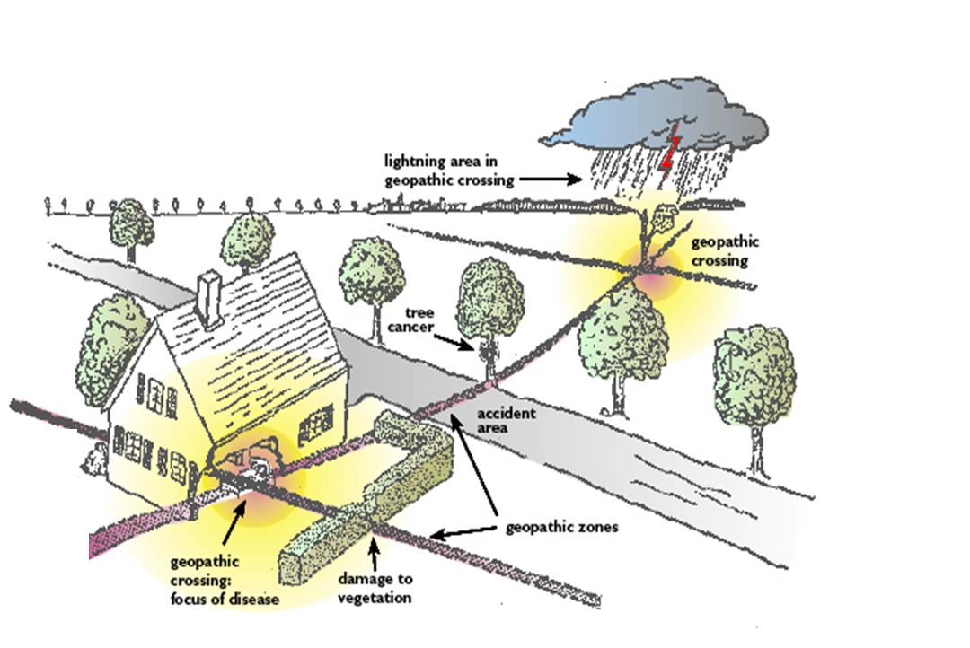
- 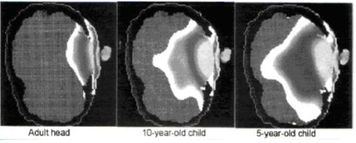Cell Phone



