Foot Detox Color Chart

For the interpretation of detoxified Material
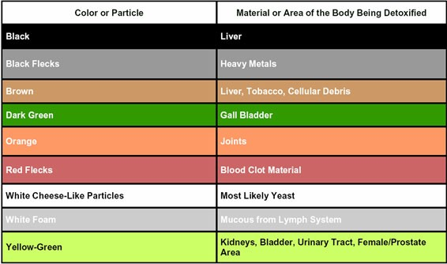

​ALL RIGHTS RESERVED. NO STATEMENT OR PRODUCT HAS BEEN EVALUATED BY THE FDA AND IS NOT A SUBSTITUTE FOR YOUR MEDICAL DOCTOR. PLEASE SEE FULL DISCLAIMER FOR MORE DETAILED INFORMATION. BY VIEWING ANY ADDITIONAL PAGE ON THIS WEBSITE YOU HAVE AGREED TO THE DISCLAIMER AND ARE AWARE OF THE FULL DISCLAIMER.

