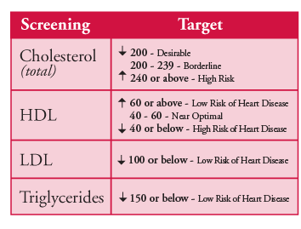

Blood Pressure, Blood Sugar, Cholesterol

Cholesterol

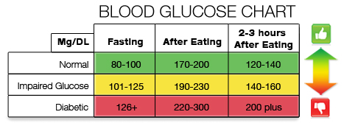

Blood Sugar

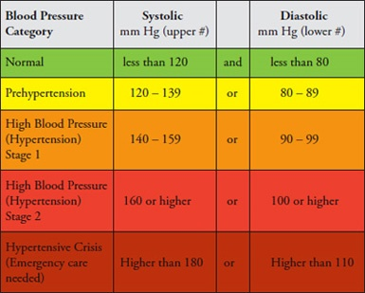

Blood Pressure